



DATABASE APPLICATIONS
(240)

National 2024
PRODUCTION
Job 1: Import/Edit Excel File and
Use Calculated Fields __________ (100 points)
Job 2: Create Table __________ (75 points)
Job 3: Relationship Report __________ (50 points)
Job 4: Query __________ (50 points)
Job 5: Report with Calculations __________ (125 points)
Job 6: Form __________ (100 points)
TOTAL POINTS __________ (500 points)

Test Time: 90 minutes

GENERAL GUIDELINES:
Failure to adhere to any of the following rules will result in disqualification:
- Member must hand in this test booklet and all printouts, if any.
- No equipment, supplies, or materials other than those specified for this event are allowed in the testing area. No previous BPA tests and/or sample tests (handwritten, photocopied, or keyed) are allowed in the testing area.
- Electronic devices will be monitored according to ACT standards.

EXAM GUIDELINES:
- Ensure this test booklet contains Jobs 1-6.
- Key all jobs according to the instructions given.
- Correct any and all formatting, spelling or grammar errors. Use the formatting guide in the Style & Reference Manual.
- Your name or initials should not appear on any work you submit. Use your Member ID in any occasion you would normally key your reference initials.
- In the lower right hand corner of ALL work submitted (unless otherwise specified), key your Member ID and job number.
- If you complete the event before the end of the time allotted, notify the proctor. Time may be considered a factor in determining a winner when there is a tie score.
- Place your scoring sheet on top of your jobs. Jobs should be placed in numerical order.

 | Points  Possible | Points  Earned
Job 1. Import/Edit Excel File and Use Calculated Fields (Concatenate)
Import data from Excel file | 10
Field names correct | 10
Named table Membership – XXXXXX | 5
Sorted data by LastName in ascending order | 10
Hide following fields: ID Number, StreetAddress, City, State, ZIP, Email, GraduationYear | 10
Create calculated text field named Salutation to combine Title and LastName fields | 40
Resize remaining columns so that all data and field names are visible | 10
Print table in portrait orientation | 5
Total for Job 1 | 100
Job 2. Create Table
Table name is Alumni Gear – XXXXXX | 10
Field names entered correctly (no spaces) | 10
Data entered correctly (5 points each) | 30
Field type for ItemPrice field is currency | 10
Export table in text format | 10
Print text file in portrait orientation | 5
Total for Job 2 | 75
Job 3. Relationship Report
Create a relationship between the GearPurchase field in the Membership – XXXXXX table and the Item field in the Alumni Gear – XXXXXX table | 20
Name the report “Relationship Report” | 5
Remove the date and time from the report header | 5
Expand the tables in the report so that all fields are visible | 5
Include a right footer with Member ID on one line and Job 3 beneath on next line | 10
Print the relationship report in portrait orientation | 5
Total for Job 3 | 50
Job 4. Query
Query includes FirstName, LastName, DuesPayment, GearPurchase, and ItemPrice fields | 30
Query saved as Member Purchase – XXXXXX | 10
Query printed in portrait orientation | 10
Total for Job 4 | 50
Job 5. Report With Calculations
Report created using Member Purchase – XXXXXX query including LastName, FirstName, DuesPayment, GearPurchase and ItemPrice fields | 20
Tax field added, calculating 6% tax on ItemPrice | 30
Tax field formatted as currency with 2 decimal places | 15
Report is grouped by GearPurchase field | 10
Report is sorted by LastName within grouping | 10
Detail fields are resized so that all information is visible | 10
Report is named “Member Sales Tax” | 10
Inserted right footer with Member ID on one line and Job 5 on a second line | 10
Report printed in portrait orientation, ensuring all five fields fit horizontally on page | 10
Total for Job 5 | 125
Job 6. Form
Form created from Membership table with Title, FirstName, LastName, MembershipDate, DuesPayment, GearPurchase, and Salutation fields | 20
Form is named “Membership” in Access objects panel on left of printed screen | 10
Six items entered in combo box correctly beginning with “Tshirt ($15.00)” and ending with “Water Bottle ($20.00) | 30
Record shown is for Ms. Reika Evans and shows dropdown combo box items | 20
Screen print of record is in portrait orientation | 10
Member ID and Job 6 visible on bottom of Membership form | 10
Total for Job 6 | 100
Total Points Earned | 500

Job 1 – Import/Edit Excel File and Use Calculated Fields (table will be on 3 pages)
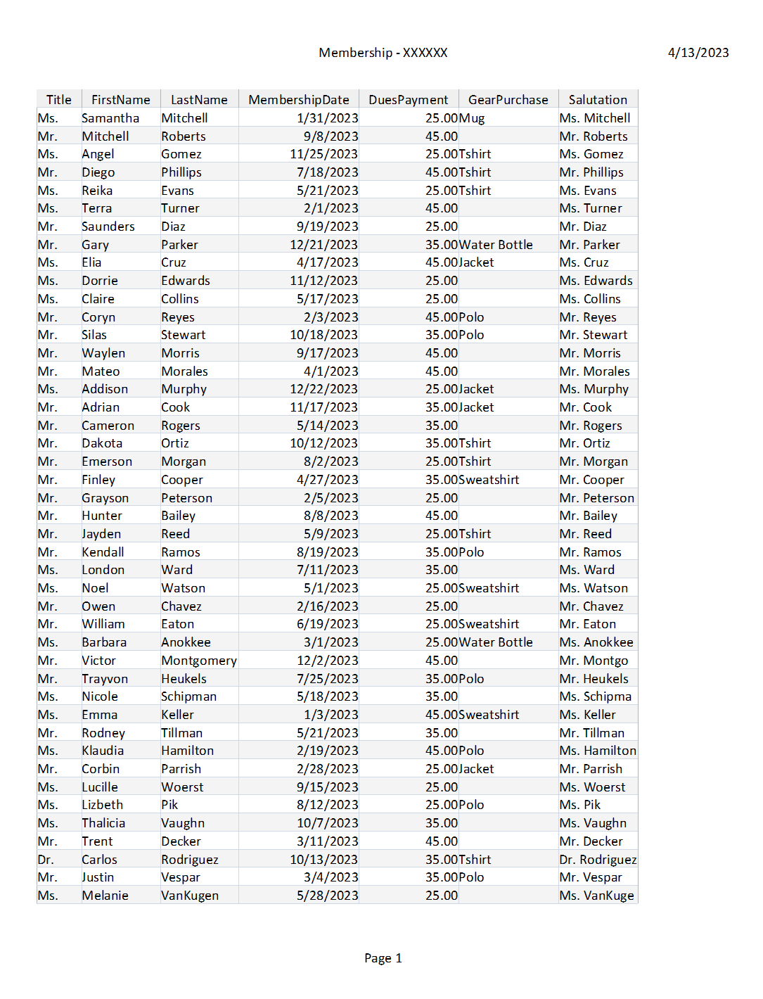
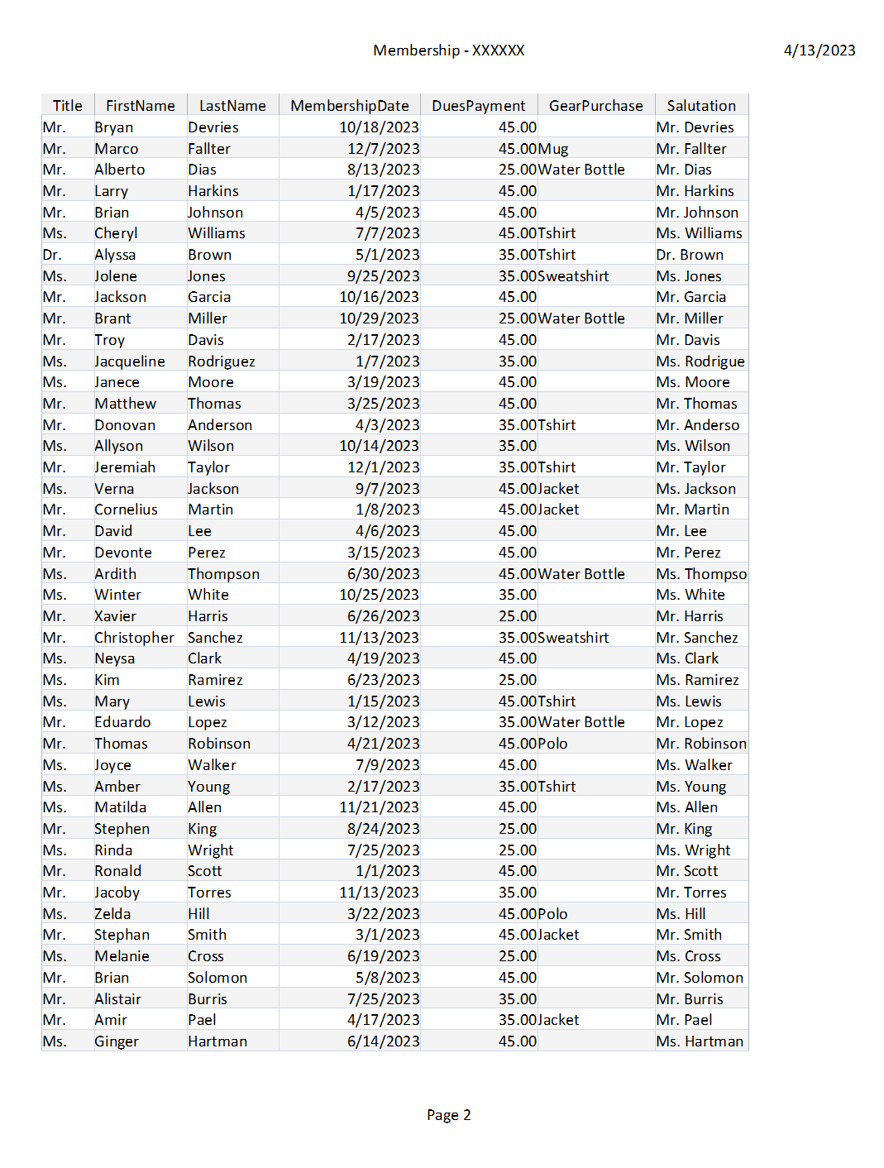

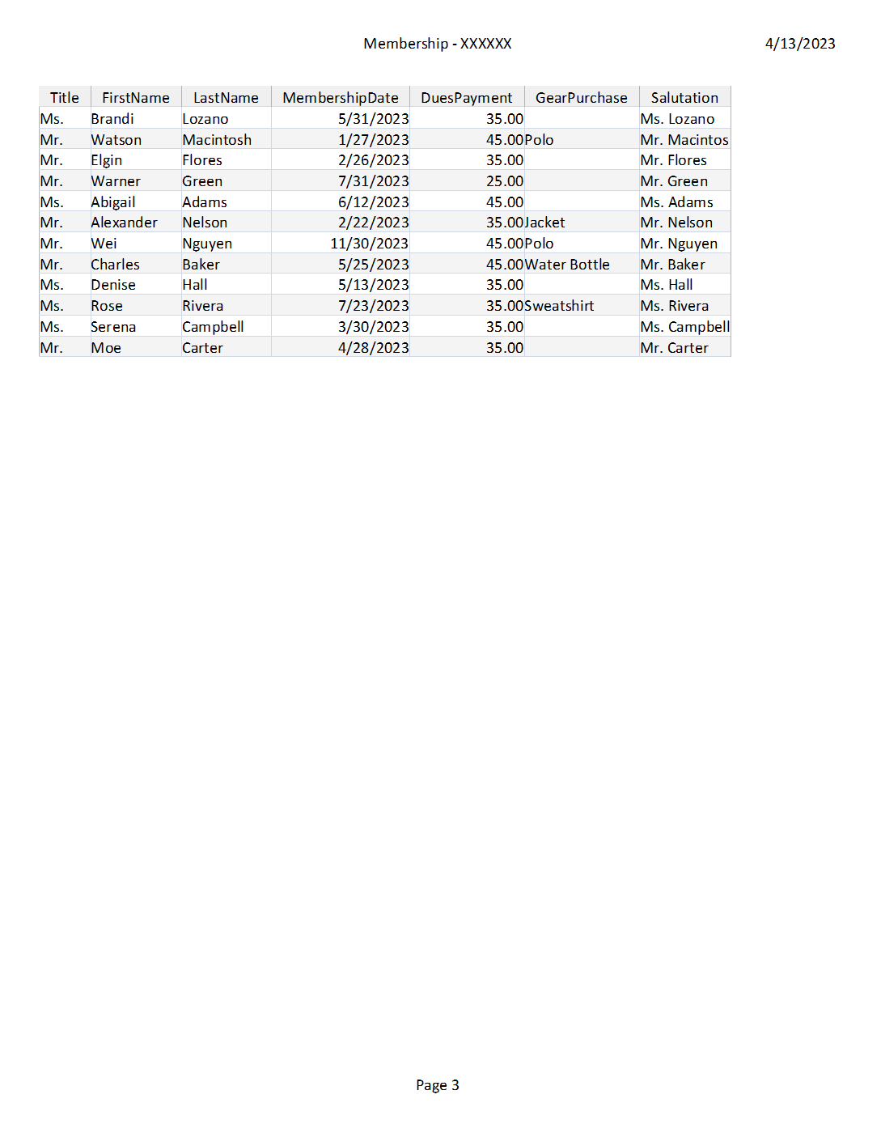

Job 2 – Create Table/Export to Text File
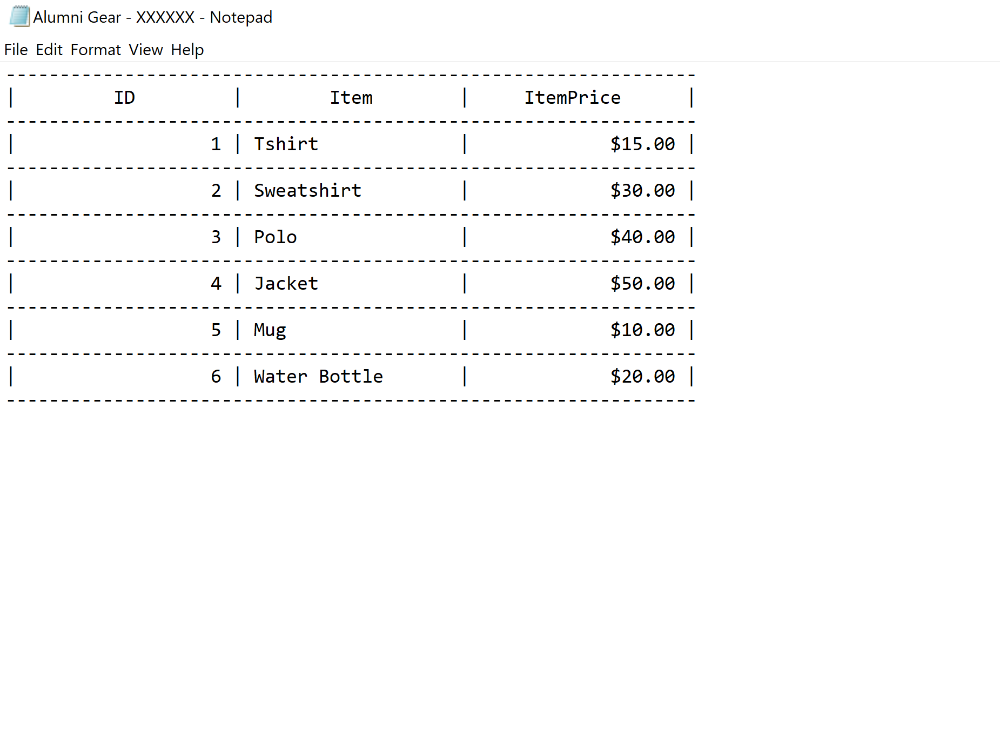
Job 3 – Relationship Report

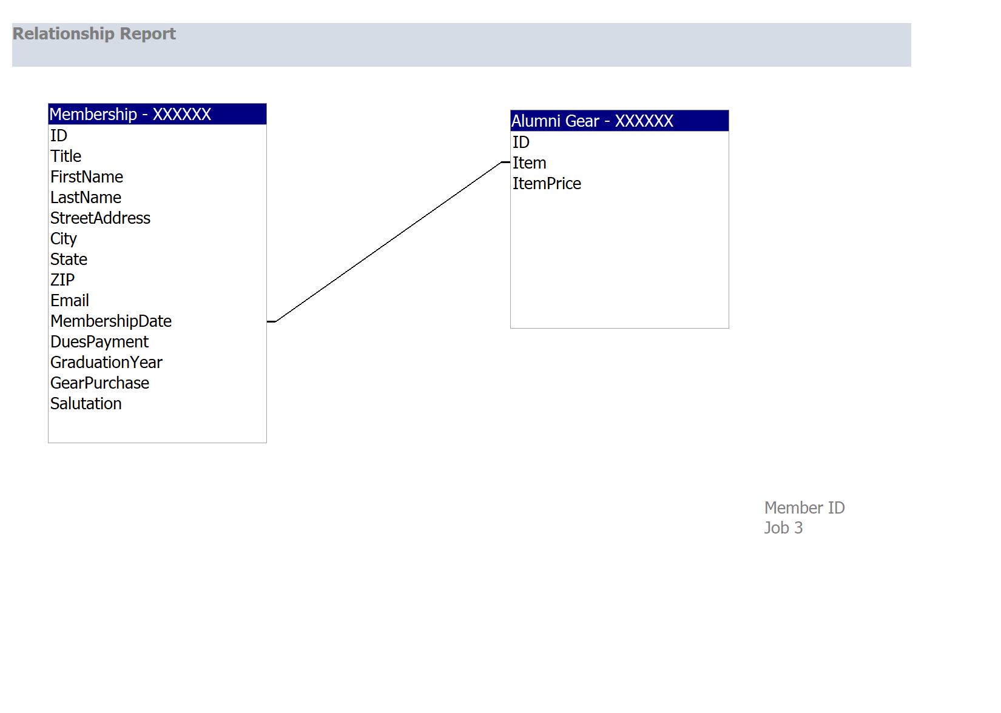

Job 4 – Query
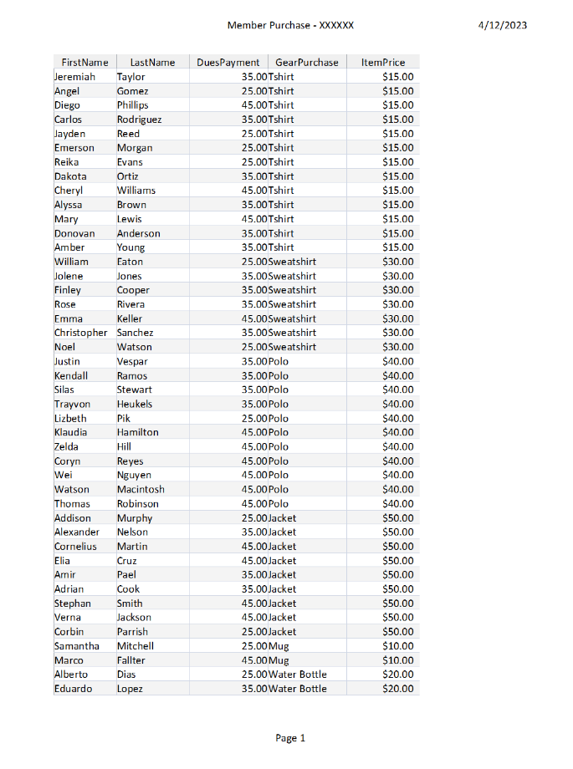

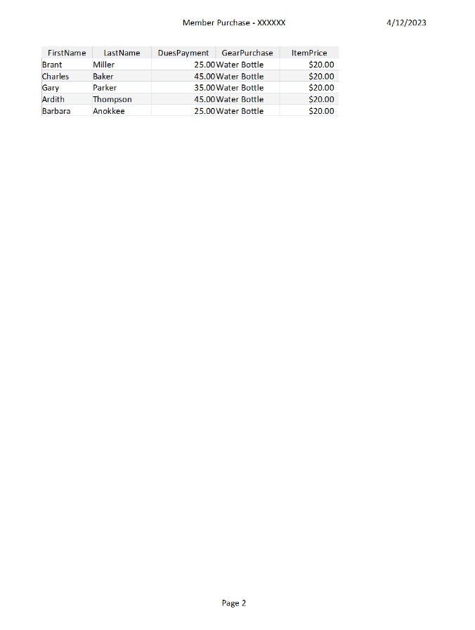
Job 5 – Report With Calculations
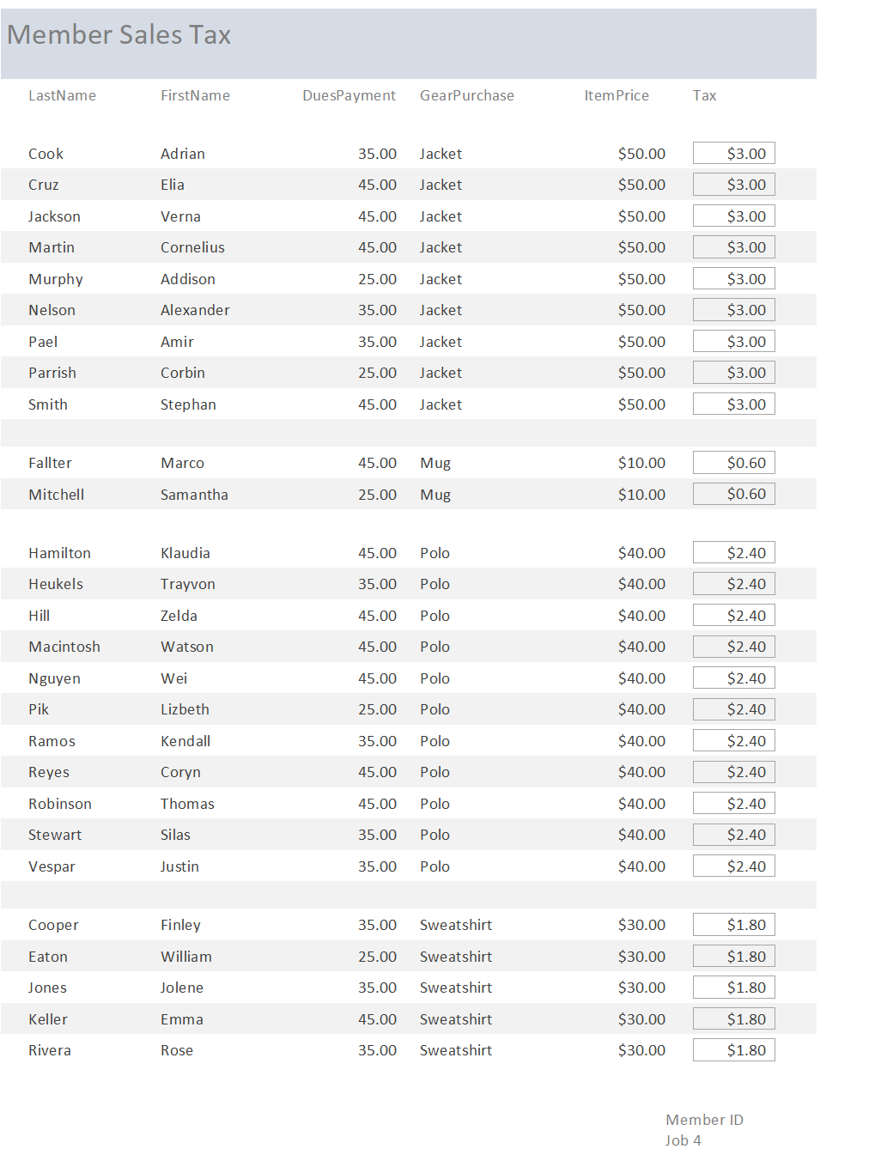

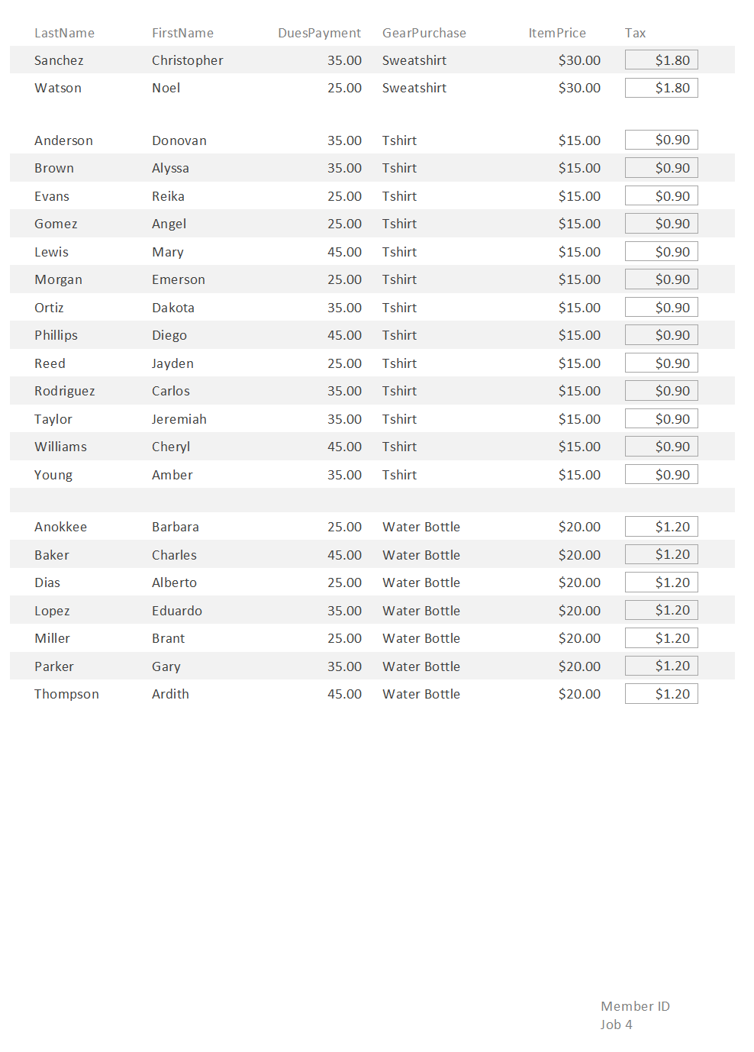
Job 6 – Alumni Info Form
